3.65: Take 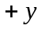 to be upward. The vertical motion of the rocket is unaffected by its horizontal velocity.
a) 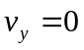 (at maximum height),
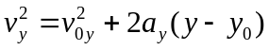 gives 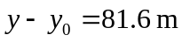
b) Both the cart and the rocket have the same constant horizontal velocity, so both travel the same horizontal distance while the rocket is in the air and the rocket lands in the cart.
c) Use the vertical motion of the rocket to find the time it is in the air.
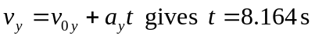
Then
d) Relative to the ground the rocket has initial velocity components 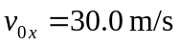 and 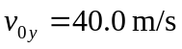, so it is traveling at 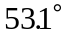 above the horizontal.
e) (i)
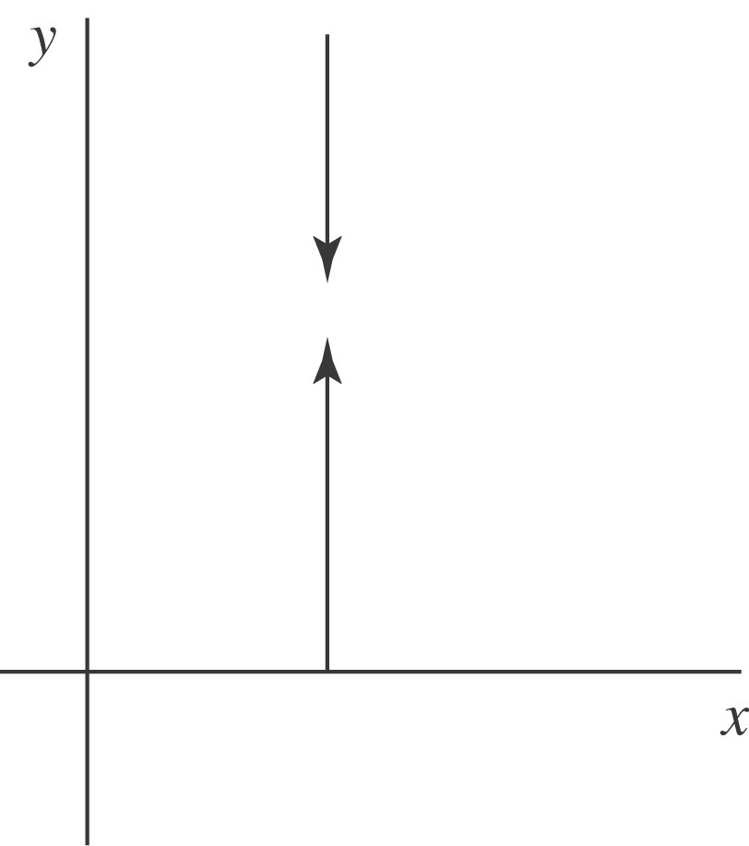

Relative to the cart, the rocket travels straight up and then straight down
(ii)
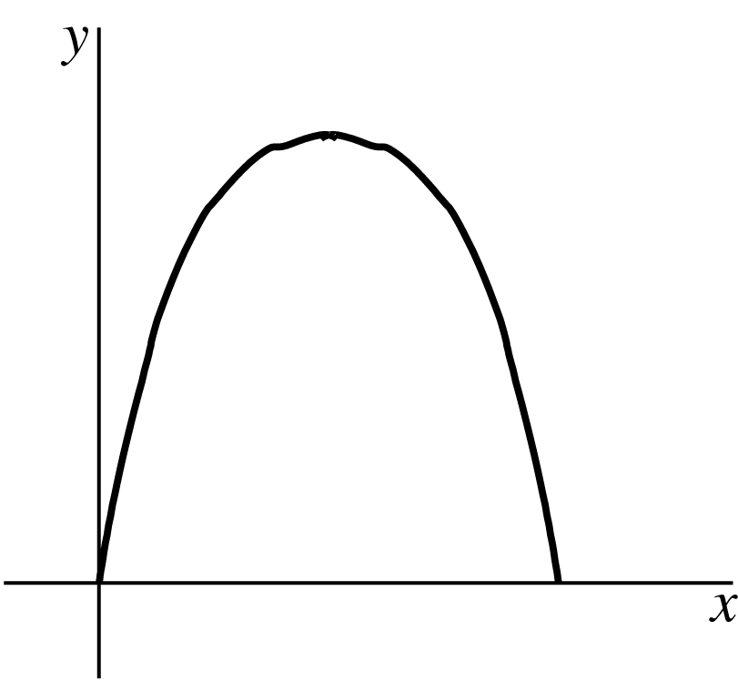

Relative to the ground the rocket travels in a parabola.

